Video tutorials of MESMER
This is a video tutorial plan of the MESMER project. The following sections will put verbal scripts and visual descriptions of screens about how to go through each step in respective tasks. The visual description of the screens will be surrounded by a pair of angle brackets, addressing the focus of the screen and the key steps of the mouse/keyboard actions.

Downloading and installing MESMER

Windows
<MESMER title and tutorial name; no application is brought up.>
Hi,

This is the first tutorial of MESMER just to guide you how to download and install it. There are currently two ways of installation. One is the Windows installation package, the other is the source code. If you are familiar with how to install Windows version of MESMER, you can skip the first part of this tutorial. The second part of this tutorial briefly talks about the Subversion repository on SourceForge website and how to update the source code through a text based console.

Now I am going to show you where to download the Windows installation package and how to install it.

If you happen to see this video tutorial, you already know how to get to the SourceForge website. Or if unfortunately you still don’t know where to download the files, just type in “sourceforge MESMER” in any search engine, MESMER should appear in the first link.

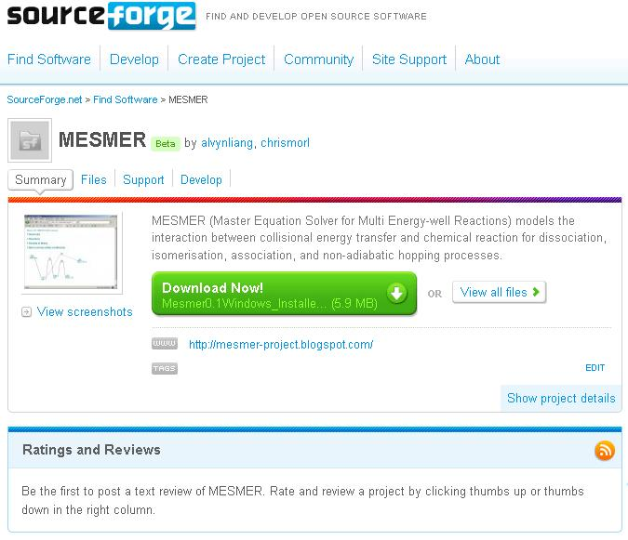

Now, to download the latest packaged Windows installer, just click on the Download Now! Link and save it to somewhere. After downloading the software, you should be able to install MESMER on your PC by double clicking on the installer.

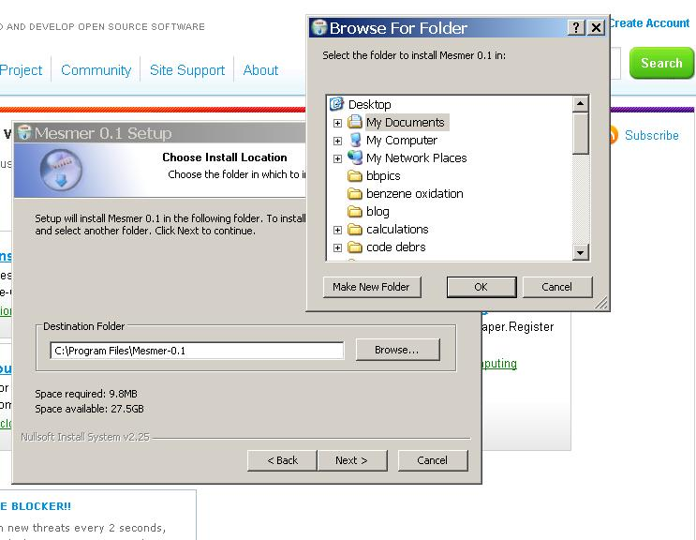

Install MESMER into a convenient place. There is no suggestion for the best place to install it; however, as later you will need to run the MESMER executable in the console, it is sensible not to put MESMER somewhere difficult to find.

The next thing to do will be checking the Environment Variables of your Windows machine. Locate “Properties” by right-clicking on “My Computer”. A box called “System Properties” will pop up. Then, go to “Advanced”, and find “Environment Variables”. In this box, there is a variable called MESMER_DIR. You will need to modify its value so that MESMER knows where to find itself.

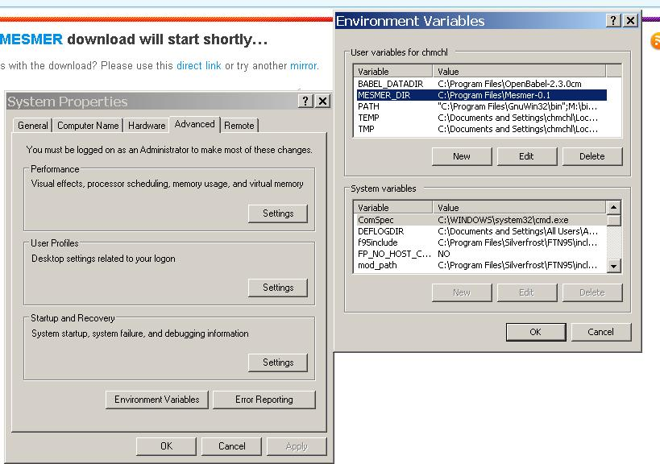

Suppose you install it in “C:\Program files\Mesmer-0.1”, what you need to do is go to the console by going to Windows → Run and enter cmd in the text box and hit Enter button.

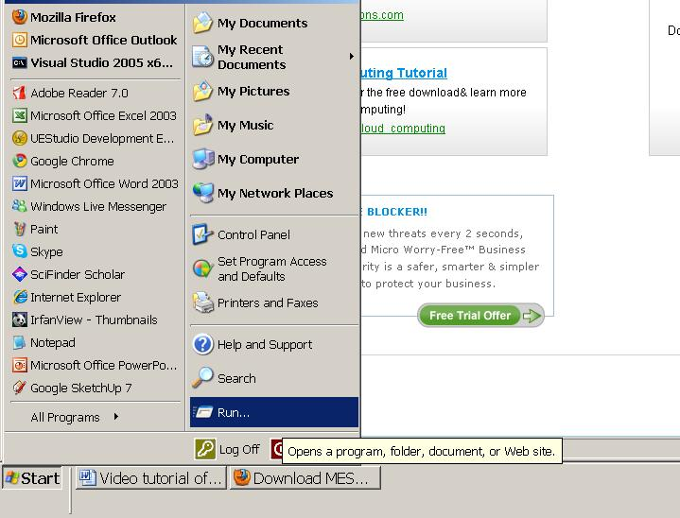

Go to the folder you installed MESMER in the console and type qa and Enter in MesmerQA folder.

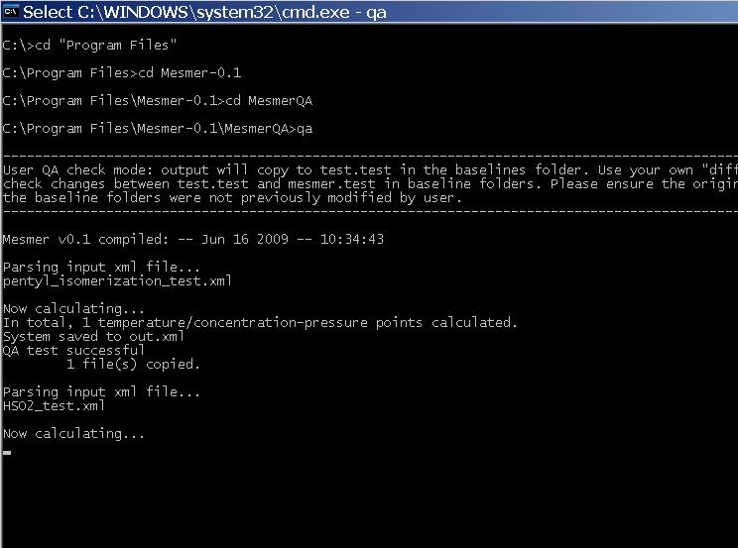

Now you should be able to see the above screen showing the console is running MESMER quality assessment calculations. In the end of each calculation, you will see a line saying “QA test successful” if the calculated result is identical to what we produced on our machine.

If everything goes fine until this step, you have configured MESMER correctly. One thing to know about the installed version of MESMER is that if you move the folder to somewhere else; for example, to the Desktop, you will need to go back to “Environment Variables” and set MESMER_DIR to whatever position you have relocated it to. If you install multiple copies of MESMER in your computer, only one path should be defined for MESMER_DIR, otherwise MESMER will not run. <MESMER_DIR problem needs to be resolved first>

Downloading the source code
If you are using Cygwin or Linux like systems, you can download the source code using a Subversion client. The place to look at how to download it is located in the Code section of the MESMER page on SourceForge. Providing if you have installed Subversion in the terminal, simply type the following in the terminal,
svn co https://mesmer.svn.sourceforge.net/svnroot/mesmer mesmer
in the folder you wish to put MESMER in.
Every once a while, MESMER source code is updated for better stability and precision. User can use the following command to update their copy of MESMER source code:
svn update
Alternatively, there are many Subversion clients on Internet. Type “svn client Windows” in search engine and you shall be able to find many free or commercial Subversion clients. See http://subversion.tigris.org/ for more detail.

Compilation and debugging in Visual Studio
Currently MESMER can work on two versions of Visual Studio: VC8 and VC9. User need to buy Visual Studio or download Visual Studio Express (free).
Open Visual Studio by going to
\mesmer\Windows VC8
or
\mesmer\Windows VC9
Double-click on MESMER.sln
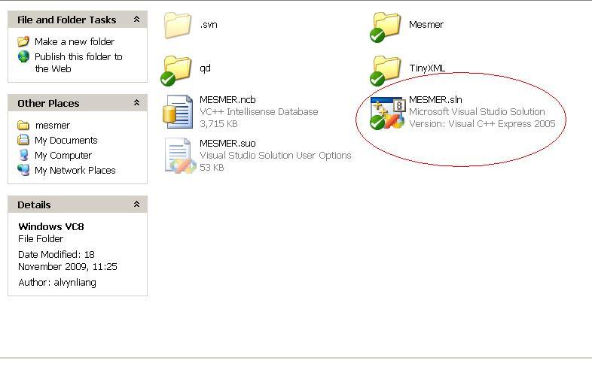
When the solution is opened, use your keyboard command Ctrl+Alt+F7 to recompile the program every time you make any modifications to the code.
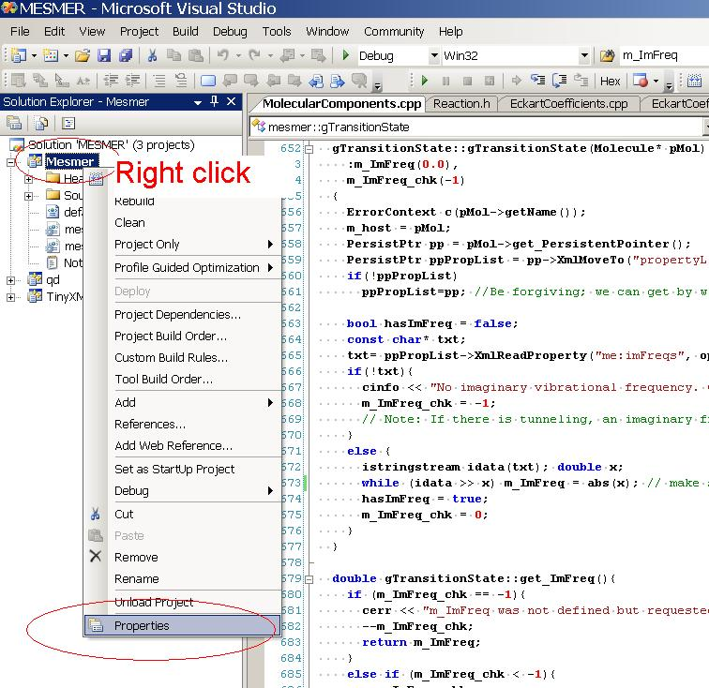
If you like MESMER to perform test run on some XML input file, right click on MESMER project under Solution ‘MESMER’, and go click on Properties. The following screen will pop up. Click on Debugging, enter the file name in the Command Arguments, and enter the path into the Working Directory; then click OK to leave the screen. You can now hit Run, or F5 to perform test run on the file you specified. If you put –N in front of the filename you entered in Command Arguments, you will get a MESMER test file with the same name as your input filename.
Please refer to the MESMER manual for more detailed descriptions.
For debugging in Visual Studio, there is more information on Internet. If you need more information please email us for detail.
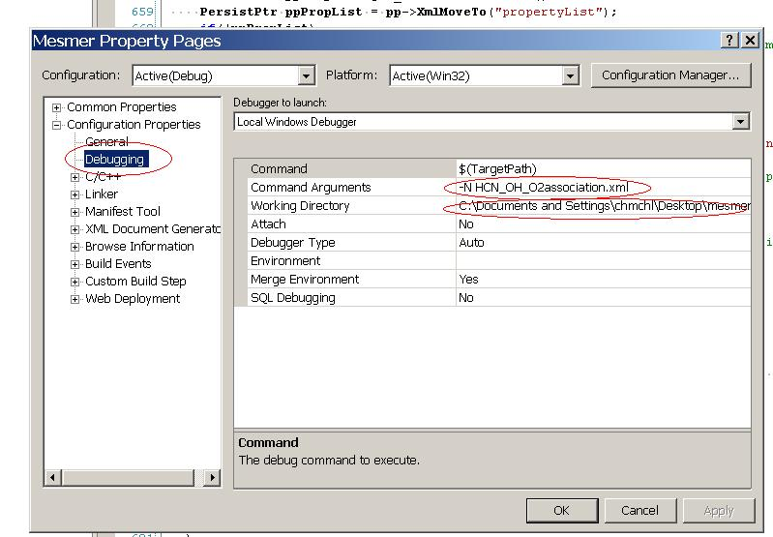

Writing a plug-in class

Matters need attention in kinetics simulations

Interpretation of data from electronic structure calculations

PES: Level of theories to be used

Spin contamination

Vibrational frequencies

Using ILT for association rate

Hindered rotor approximation

